Terremotos y huracanes Me llamo .
1. What country was affected by two major earthquakes in the past two weeks?____________________

2. September 19 was the 32nd anniversary of what in Mexico?___________________________________

3. When the rescuers raise a fist in the air, what does it signal?__________________________________

4. At SLMS, what is a signal many teachers use to get their class silent?___________________________

5. What countries were affected by Hurricane Maria?

6. What is the difference between a hurricane and an earthquake?

7. Which can be in a weather forecast? Hurricane or earthquake?
8. Which is a surprise? Hurricane or earthquake?

9. Name the types of damage each natural disaster causes:
Hurrricane | Earthquake

10. This map from the U.S. Geological Survey’s website shows all of the earthquakes in the region for September 2017. How many earthquakes did they record in those 21 days?__________________
11. Write a list of all of the countries affected by earthquakes in the map below

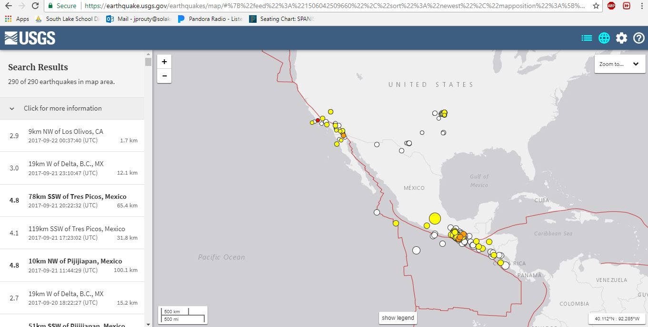

12. On the map below, draw a line on the border between México and the country to the east.
13. What is the dark gray area in the map where most of the earthquakes occurred?___________________
14. What kind of problems would earthquakes there cause?_______________________________________
15. Name the two states of Mexico where earthquakes have occurred in the past 7 days (yes they have states, like we do to divide the country into smaller parts)
_________________________________________ & _______________________________________
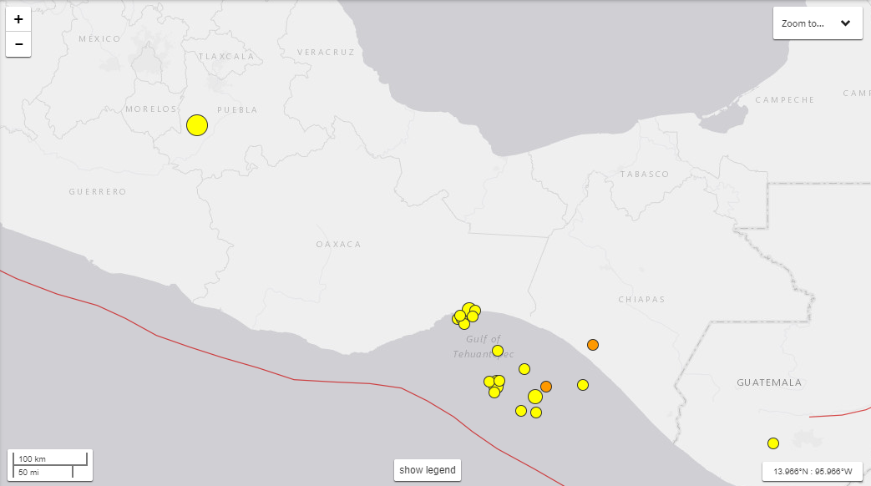
Pacific Ocean

