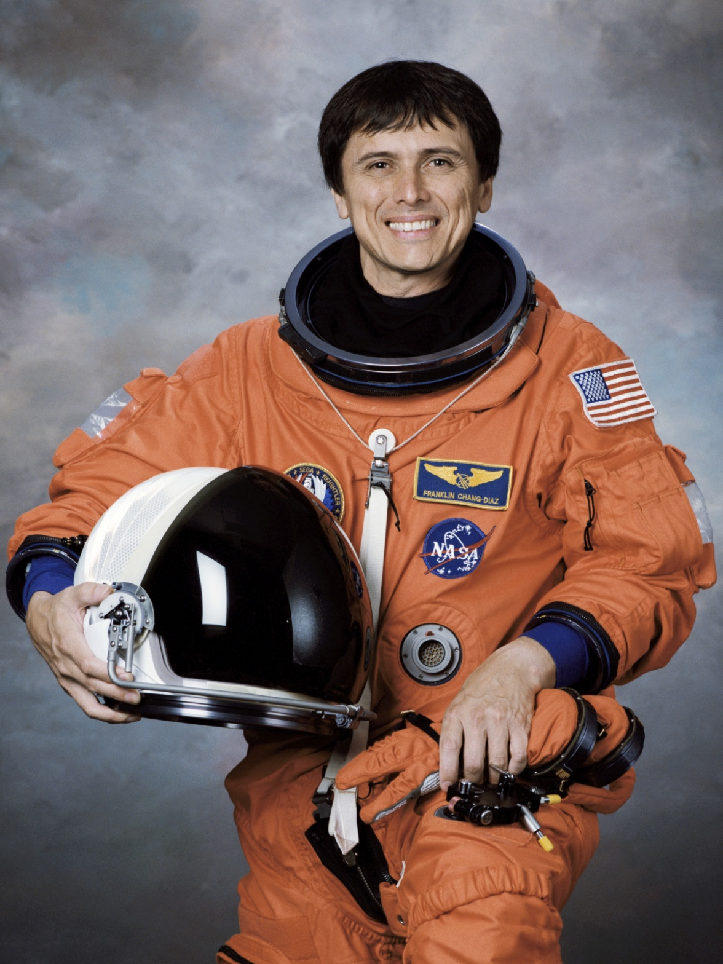
Franklin Chang Díaz –
Costa Rican American
He worked as a NASA astronaut for 25 years. Mr. Chang Díaz travelled into space SEVEN times!
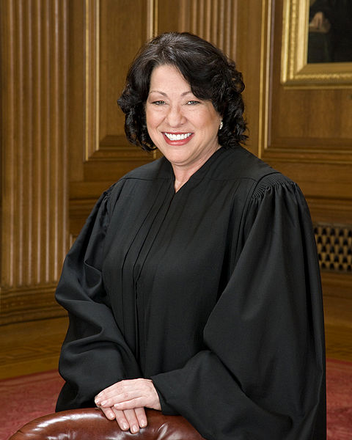
Sonia Sotomayor –
Puerto Rican American
She is the first Hispanic American Supreme Court Judge.

Detroit Tigers Baseball Players - Hispanic Americans
2012 season
Al Albuquerque- from the Dominican Republic
Joaquin Benoit- from the Dominican Republic
Miguel Cabrera- from Venezuela
Octavio Dotel- from the Dominican Republic
Omar Infante- from Venezuela
Victor Martinez- from Venezuela
Jhonny Peralta- from the Dominican Republic
Ramon Santiago- from the Dominican Republic
Anibal Sanchez- from Venezuela
Jose Valverde- - from the Dominican Republic

César Millán –
Mexican American
He is a famous dog trainer.

Carlos Santana –
Mexican American
He is a famous guitar player.

